Backlink Performance Analysis (Oct’ 26 )

Source
Semrush, GSC, Moz

URLs Tracked
15
Total pages monitored

Keywords Tracked
35
Total keywords monitored
Plan Total Backlinks (Till Oct)
480
Actual Total Backlinks (Till Oct)
423

Business Impact of Backlinks
Source: GSC
Oct’26
remote desktop - 8
remote desktop software - 25
remote access - 5
remote access software - 1
remote support - 14
remote support software - 101

teamviewer alternative - 6
teamviewer pricing - 5
logmein alternative - 10
logmein pricing - 43
anydesk alternative - 6
anydesk pricing - 4
patch management - 8
patch management software - 101
autonomous endpoint management - 6

Dec’25
remote desktop - 12
remote desktop software - 20
remote access - 7
remote access software - 13
remote support - 8
remote support software - 12
teamviewer alternative - 7
teamviewer pricing - 20
logmein alternative - 22
logmein pricing - 11
anydesk alternative - 20
anydesk pricing - 8
patch management - 62
patch management software - 101
autonomous endpoint management - 14

Remote access keywords continue to show strong performance, with 'remote access software' securing the #1 position and 'remote access' maintaining a top 5 ranking. 'Remote desktop' also improved from position 12 in Dec’25 to 8 in October, entering the top 10.
Most of the competitor keywords showed significant improvement, with 5 keywords now ranking in the top 10 positions.
Patch management and endpoint management keywords continue to show strong performance, with 2 out of 3 keywords ranking in the top 10 positions.

Referring Domains DA

Here are the Referring DA categories of the given backlinks
Referring Domain DA
DA 71 - 100 - 62
DA 41-70 - 319
DA 25 -40 - 42

Monthly Backlink Growth

Backlink monthly growth trend
Feb’ 26 Mar’26 Apr’26 May’26 June’26 July’26 Aug’ Sep,26 Oct’26
Total Backlinks
50 25 48 83 32 108 36 40 1

Keyword Ranking Performance

Keywords in Top 5

Dec’25 - 0
Oct’26 - 4

Dec’25

remote access - 7
remote access software- 13
teamviewer pricing - 20
anydesk pricing - 8

Oct’26
remote access – 5
remote access software – 1
teamViewer pricing – 5
anyDesk pricing – 4

Keywords on First Page (Top 10)
Dec‘25 - 4
Oct’26- 10

Dec’25
remote desktop - 12
remote access - 7
remote access software - 13
logmein alternative -22
teamviewer alternative - 7
teamviewer pricing - 20
anydesk pricing - 8
anydesk alternative - 20
patch management - 62
autonomous endpoint management - 14

Oct’26
remote desktop – 8
remote access – 5
remote access software – 1
teamviewer alternative – 6
teamviewer pricing – 5
logmein alternative – 10
anydesk alternative – 6
anydesk pricing – 4
patch management – 8
autonomous endpoint management – 6

Tracked URLs
- https://www.splashtop.com/blog/what-is-remote-desktop
- https://www.splashtop.com/solutions/remote-desktop
- https://www.splashtop.com/blog/what-is-remote-access
- https://www.splashtop.com/products/remote-access
- https://www.splashtop.com/blog/what-is-remote-support
- https://www.splashtop.com/products/remote-support
- https://www.splashtop.com/compare/teamviewer-alternative
- https://www.splashtop.com/blog/teamviewer-pricing-comparison
- https://www.splashtop.com/compare/logmein-alternative
- https://www.splashtop.com/compare/logmein-alternative/pricing
- https://www.splashtop.com/compare/anydesk-alternative
- https://www.splashtop.com/blog/anydesk-pricing-comparison
- https://www.splashtop.com/blog/what-is-patch-management
- https://www.splashtop.com/solutions/patch-management
- https://www.splashtop.com/blog/autonomous-endpoint-management-comprehensive-guide

Performance Summary

 | "Baseline  Dec'25" | FeFeb'26 | Mar'26 | Apr'26 | May’26 | June’26 | July’26 | Aug’26 | Sep’26 | Oct’26
Total Backlinks | - | 3 | 8 | 11 | 20 | 23 | 29 | 32 | 35 | 35
Remote Access | 7 | 6 | 7 | 5 | 6 | 4 | 5 | 5 | 5 | 5
What is remote access | 8 | 6 | 6 | 4 | 3 | 3 | 3 | 4 | 3 | 3
benefits of remote access | 2 | 3 | 2 | 2 | 3 | 3 | 3 | 3 | 3 | 2
remote desktop access | - | 20 | 18 | 11 | 21 | 10 | 8 | 9 | 11 | 12
Page Authority | 54 | 54 | 54 | 55 | 55 | 55 | 55 | 55 | 55 | 55

 | "Baseline  Dec'25" | Feb'26 Feb'26 | Mar'26 | Apr'26 | May’26 | June’26 | July,26 | Aug’26 | Sep’26 | Oct’26
Total Backlinks | - | 3 | 5 | 8 | 16 | 21 | 34 | 35 | 39 | 39
remote support | 8 | 12 | 13 | 22 | 14 | 10 | 6 | 10 | 11 | 14
what is remote support | 3 | 3 | 3 | 4 | 4 | 4 | 3 | 3 | 3 | 3
remote desktop support | 17 | 12 | 9 | 20 | 17 | 16 | 19 | 22 | 14 | 9
Page Authority | 33 | 38 | 38 | 40 | 42 | 42 | 42 | 42 | 42 | 42

 | "Baseline  Dec'25" | Feb'26 Feb'26 | Mar'26 | Apr'26 | May’26 | June’26 | July’26 | Aug’26 | Sep’26 | Oct’26
Total Backlinks | - | 12 | 15 | 29 | 43 | 47 | 61 | 69 | 73 | 73
Remote access software | 13 | 1 | 1 | 1 | 6 | 101 | 101 | - | - | 1
Remote Access Solution | 4 | 1 | 1 | 1 | - | 101 | 101 | - | - | -
remote access tool | 11 | - | - | - | - | - | 101 | - | - | -
Page Authority | 43 | 46 | 46 | 47 | 47 | 47 | 47 | 48 | 48 | 48

 | "Baseline  Dec'25" | Feb'26 Feb'26 | Mar'26 | Apr'26 | May’26 | June’26 | July’26 | Aug’26 | Sep’26 | Oct’26
Total Backlinks | - | 14 | 23 | 27 | 38 | 41 | 59 | 62 | 72 | 72
Remote support software | 12 | 11 | 82 | 5 | 1 | - | 101 | - | - | -
Remote Support Solution | 4 | 17 | 2 | 3 | 1 | - | 101 | - | - | -
remote support tool | 9 | 7 | - | - | 1 | - | 101 | - | - | -
remote it support software | 8 | 7 | - | - | - | - | 101 | - | - | -
Page Authority | 45 | 47 | 47 | 47 | 48 | 48 | 48 | 48 | 48 | 48

 | "Baseline  Dec'25" | Feb'26 Feb'26 | Mar'26 | Apr'26 | May’26 | June’26 | July’26 | Aug’26 | Sep’26 | Oct’26
Total Backlinks | - | 11 | 14 | 26 | 38 | 44 | 63 | 71 | 76 | 76
Remote desktop software | 20 | 40 | 15 | 13 | 11 | 15 | 28 | 31 | 22 | 25
Remote desktop Solution | 32 | 53 | 25 | 24 | 31 | 22 | 17 | 18 | 10 | 4
remote desktop connection software | 37 | 36 | 21 | 24 | 27 | 32 | 16 | 27 | 26 | 16
remote pc software | 38 | 56 | 24 | 18 | 40 | 45 | 44 | 39 | 23 | 18
remote desktop program | 48 | 39 | 18 | 13 | 9 | 16 | 26 | 28 | 20 | 24
remote desktop tools | 26 | 35 | 11 | 6 | 25 | 17 | 11 | 10 | 7 | 13
Remote Desktop | 12 | 42 | 29 | 27 | 27 | 15 | 5 | 6 | 9 | 8
Page Authority | 45 | 45 | 45 | 46 | 46 | 46 | 46 | 46 | 46 | 46

 | "Baseline  Dec'25" | Feb'26 Feb'26 | Mar'26 | Apr'26 | May’26 | June’26 | July’26 | Aug’26 | Sep’26 | Oct’26
Total Backlinks | - | 5 | 8 | 11 | 18 | 22 | 32 | 36 | 37 | 37
Remote Desktop | 4 | 72 | 29 | 10 | 3 | 3 | 3 | 29 | 12 | 13
What is remote desktop | 5 | 9 | 4 | 10 | 16 | 25 | 22 | 16 | 7 | 6
Page Authority | 36 | 41 | 41 | 43 | 43 | 43 | 43 | 43 | 43 | 43

 | "Baseline  Dec'25" | Feb'26 Feb'26 | Mar'26 | Apr'26 | May’26 | June’26 | July’26 | Aug’26 | Sep’26 | Oct’26
Total Backlinks | - | 1 | 1 | 2 | 3 | 3 | 6 | 7 | 9 | 9
autonomous endpoint management software | 2 | 1 | 4 | 3 | 3 | - | 101 | - | 7 | 10
Page Authority | 38 | 42 | 42 | 42 | 43 | 43 | 43 | 43 | 43 | 43

 | "Baseline  Dec'25" | Feb'26 Feb'26 | Mar'26 | Apr'26 | May,26 | June’26 | Jul’26 | Aug’26 | Sep’26 | Oct’26
Total Backlinks | - | - | - | - | 2 | 2 | 4 | 4 | 4 | 5
anydesk pricing | 8 | 7 | 6 | 6 | 8 | 5 | 4 | 4 | 4 | 4
Page Authority | 54 | 41 | 41 | 42 | 42 | 42 | 42 | 42 | 42 | 42

 | "Baseline  Dec'25" | Feb'26 Feb'26 | Mar'26 | Apr'26 | May’26 | June’26 | July’26 | Aug’26 | Sep’26 | Oct’26
Total Backlinks | - | - | - | - | 2 | 2 | 4 | 4 | 5 | 5
teamviewer pricing | 20 | 11 | 8 | 7 | 8 | 9 | 5 | 5 | 4 | 5
Page Authority | 41 | 41 | 41 | 41 | 41 | 41 | 41 | 41 | 41 | 41

 | "Baseline  Dec'25" | Feb'26 Feb'26 | Mar'26 | Apr'26 | May’26 | June’26 | July’26 | Aug’26 | Sep’26 | Oct’26
Total Backlinks | - | - | - | - | 2 | 2 | 4 | 4 | 5 | 5
anydesk alternative | 20 | 16 | 9 | 29 | 24 | 24 | 19 | 7 | 9 | 6
Page Authority | 40 | 40 | 40 | 40 | 40 | 40 | 40 | 40 | 40 | 40

 | "Baseline  Dec'25" | Feb'26 Feb'26 | Mar'26 | Apr'26 | May’26 | June’26 | July '26 | Aug’26 | Sep’26 | Oct’26
Total Backlinks | - | - | - | - | 2 | 2 | 4 | 5 | 5 | 5
logmein alternative | 22 | 21 | 7 | 13 | 22 | 21 | 17 | 18 | 9 | 10
Page Authority | 39 | 40 | 40 | 40 | 40 | 40 | 40 | 40 | 40 | 40

 | "Baseline  Dec'25" | Feb'26 Feb'26 | Mar'26 | Apr'26 | May’26 | June’26 | July’26 | Aug’26 | Sep’26 | Oct’26
Total Backlinks | - | - | - | - | 2 | 2 | 4 | 4 | 5 | 5
teamviewer alternative | 7 | 6 | 5 | 8 | 5 | 9 | 9 | 5 | 2 | 6
Page Authority | 43 | 43 | 43 | 43 | 43 | 43 | 43 | 43 | 43 | 43

 | "Baseline  Dec'25" | Feb'26 Feb'26 | Mar'26 | Apr'26 | May’26 | June’26 | July’26 | Aug’26 | Sep’26 | Oct’26
Total Backlinks | - | - | - | - | 2 | 2 | 4 | 4 | 5 | 5
logmein pricing | 11 | 14 | 18 | 32 | 31 | 35 | 32 | 39 | 44 | 43
Page Authority | 54 | 39 | 39 | 38 | 39 | 39 | 39 | 39 | 39 | 39

 | "Baseline  Dec'25" | Feb'26 Feb'26 | Mar'26 | Apr'26 | May’26 | June’26 | July’26 | Aug’26 | Sep’26 | Oct’26
Total Backlinks | - | - | - | 3 | 6 | 10 | 13 | 14 | 16 | 16
patch management | 62 | 34 | 20 | 16 | 12 | 9 | 8 | 6 | 6 | 8
what is patch management | 29 | 17 | 11 | 10 | 8 | 3 | 4 | 2 | 3 | 3
Page Authority | 37 | 35 | 35 | 37 | 38 | 38 | 38 | 38 | 38 | 38

 | "Baseline  Dec'25" | Feb'26 Feb'26 | Mar'26 | Apr'26 | May’26 | June’26 | July’26 | Aug’26 | Sep’26 | Oct’26
Total Backlinks | - | - | - | 4 | 9 | 11 | 19 | 24 | 28 | 28
patch management software | - | 50 | 35 | 39 | 39 | - | – | - | - | -
automated patch management solution | 28 | 21 | 11 | 12 | 29 | - | - | - | 42 | 40
patch management solution | 24 | 26 | 32 | 34 | 34 | - | - | - | - | 1
Page Authority | 33 | 33 | 33 | 38 | 39 | 39 | 39 | 39 | 39 | 39

 | "Baseline  Dec'25" | Feb'26 Feb'26 | Mar'26 | Apr'26 | May’26 | June’26 | July’26 | Aug’26 | Sep’26 | Oct’26
Total Backlinks | - | - | - | 1 | 2 | 3 | 5 | 6 | 7 | 7
autonomous endpoint management | 14 | 5 | 7 | 7 | 5 | - | 2 | 5 | 5 | 6
Page Authority | 33 | 33 | 33 | 33 | 35 | 35 | 35 | 35 | 35 | 35

Implementation Details
Detailed Monthly Backlinks Sheet -
Splashtop: Monthly Backlinks 2026

Should look like this
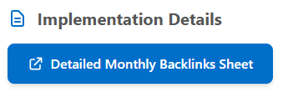

Key Findings

- First-page keyword visibility expanded in October, with 10 out of 15 target keywords ranking in the top 10 positions, reflecting stronger organic search presence.
- 'Remote access software' achieved the #1 ranking in October, marking a strong recovery after remaining unranked for several months.
- Competitor keywords continue to show strong performance, with 5 out of 6 keywords ranking in the top 10 positions, including 2 keywords in the top 5.
- The backlink profile continues to maintain strong domain quality, with approximately 90% of referring domains having a DA between 41–100.

LLM Highlights:
- Strongest AI Visibility Across Key Categories

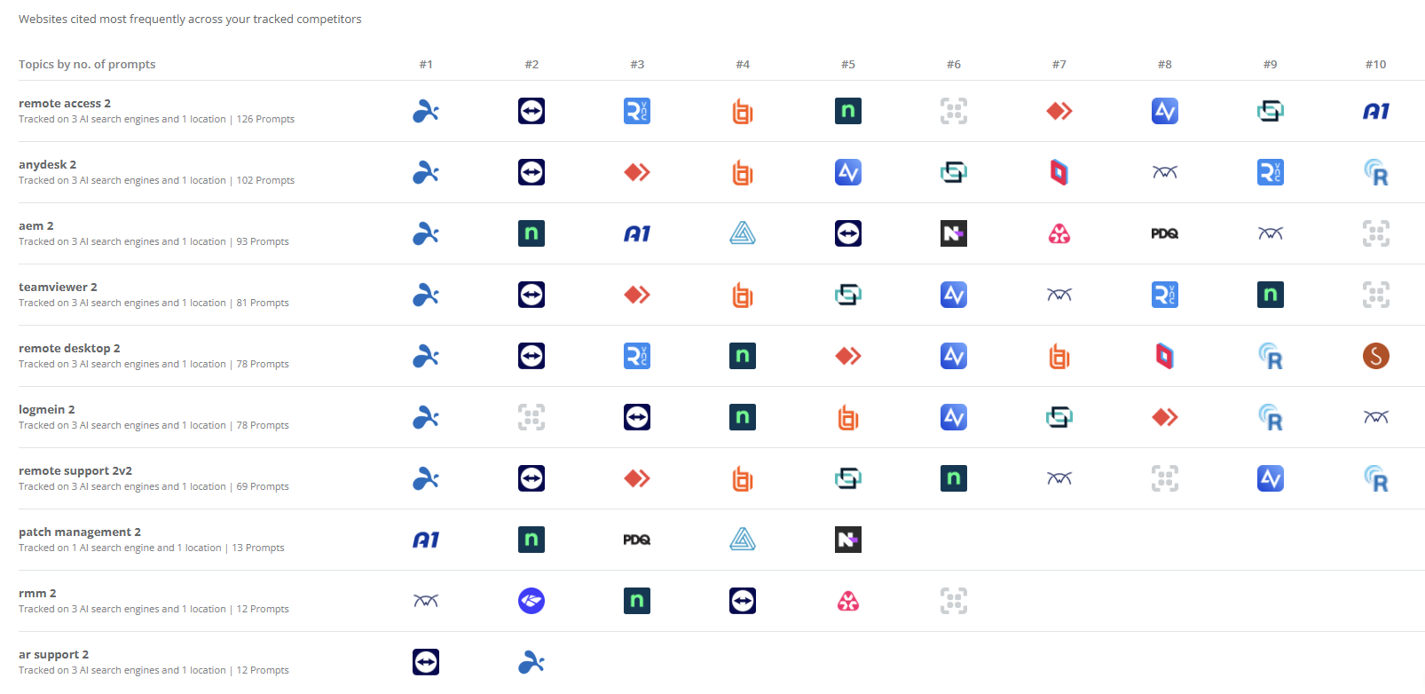

Splashtop achieves AI visibility across 8 of the 10 tracked priority topics, with first position across 7 topics, demonstrating broad and consistent presence across key solution categories.

- Splashtop Leads AI Brand Mentions Across 10 Topics

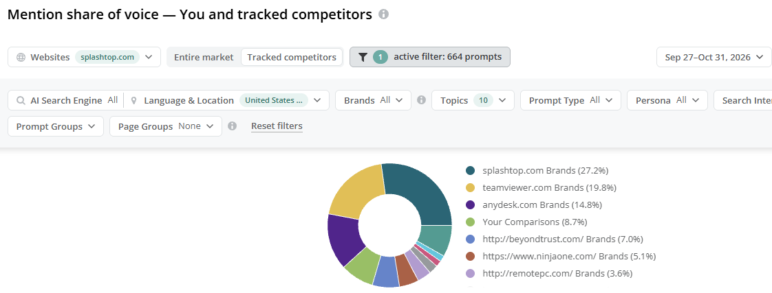

Splashtop accounted for 27.2% of brand mentions across 10 tracked categories, securing the largest overall share among competitors and establishing itself as the most prominent brand in the tracked AI conversations.

- Leading AI Citation Share in Remote Access

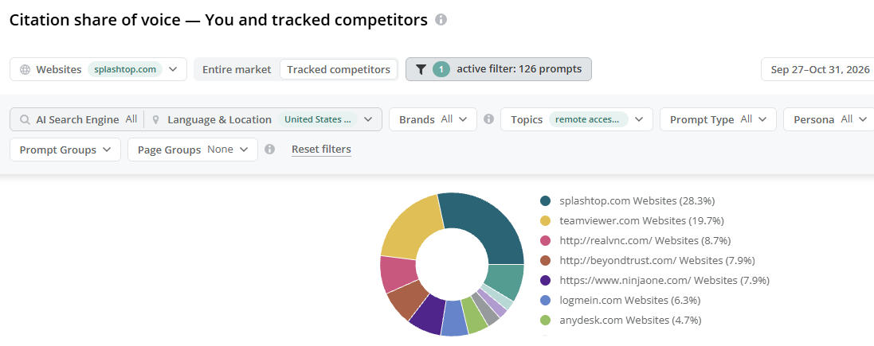

Splashtop secured the highest share of AI-generated website citations in the Remote Access category at 28.3%, establishing a clear lead over tracked competitors and reinforcing its authority across AI-generated responses.

- Remote Desktop Queries Drive Strong AI Citation Presence
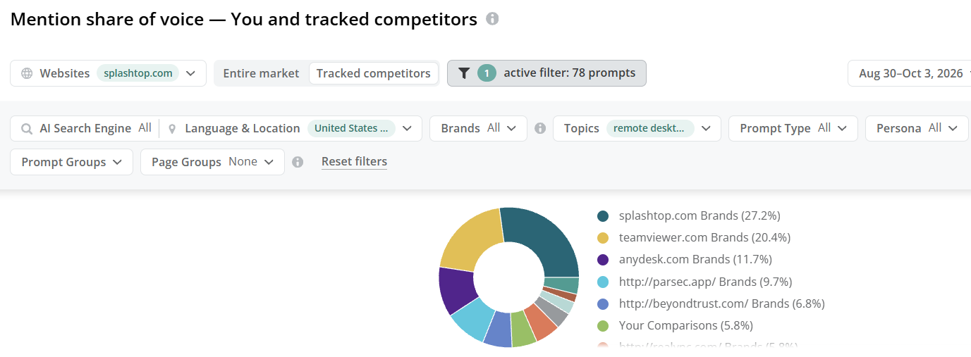

Splashtop accounts for 33.3% of AI-generated website citations across tracked Remote Desktop prompts, securing the largest share among competitors and strengthening its authority in AI-generated discussions around the category.

- High AI Citation Share in Remote Support
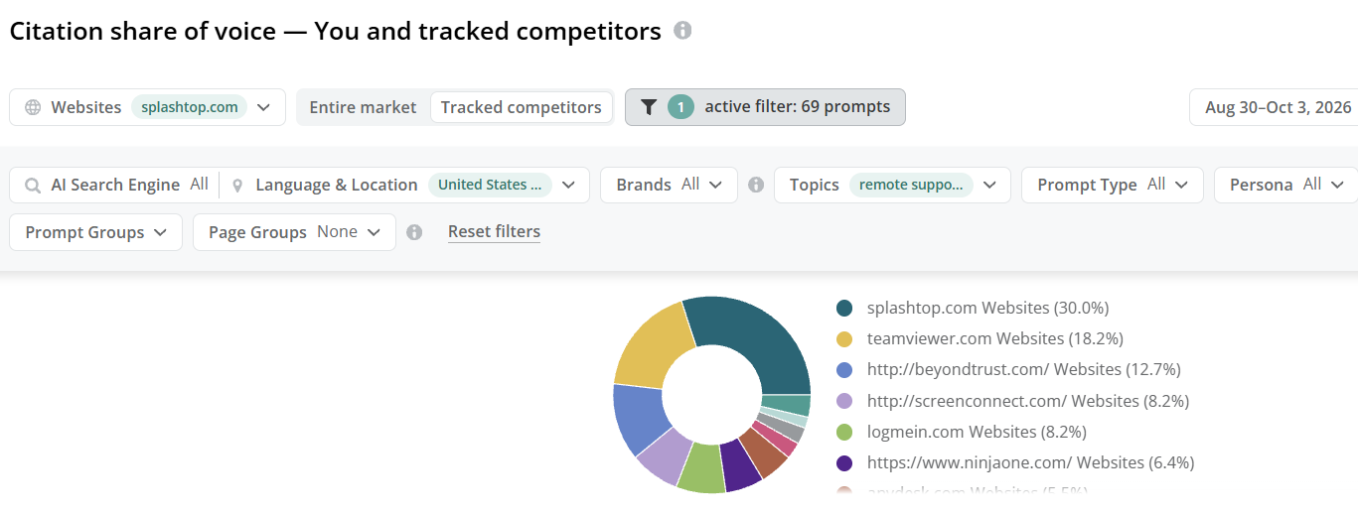
Splashtop captured 30.3% of AI website citations for Remote Support, approximately 1.3x the share of the next competitor, highlighting its strong citation presence across the category.

- Dominant AI Brand Presence in AEM

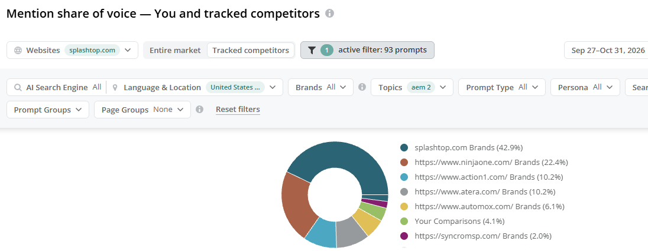

Splashtop captures 42.9% of AI brand mentions in the AEM category, nearly 2x the next competitor, highlighting a significant lead in AI-generated AEM discussions.

Highlights

- “Remote Access” Maintains Top 5 Search Visibility

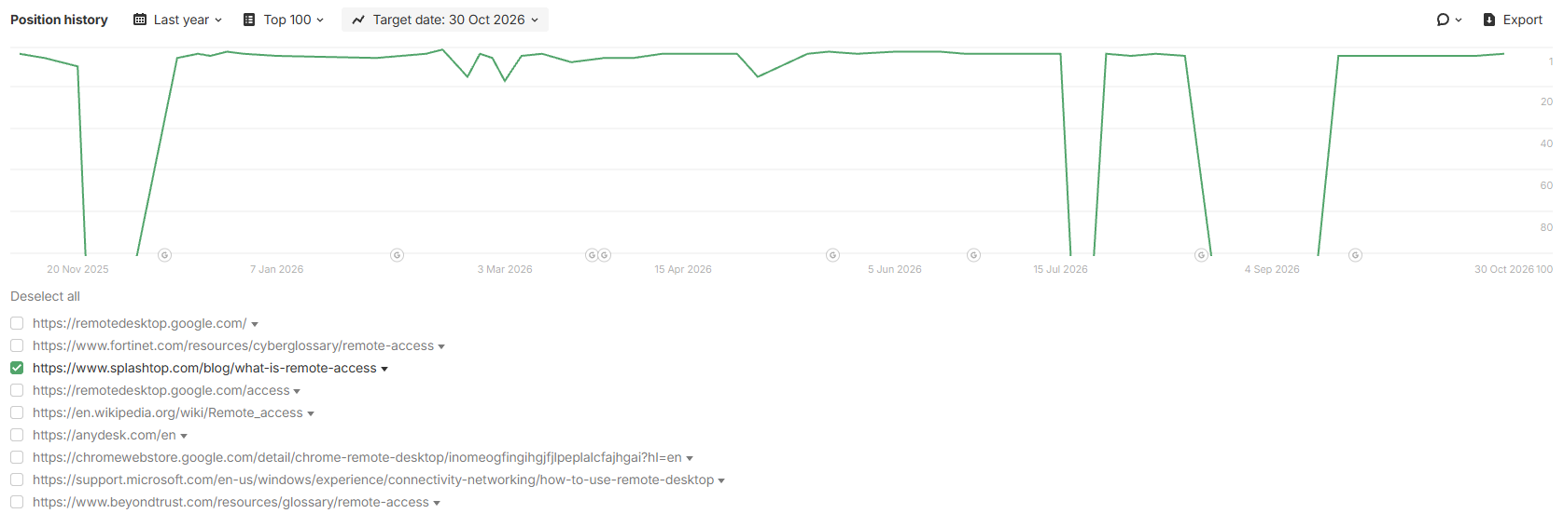

Splashtop continues to hold a Top 5 position for the “remote access” keyword after recovering from temporary volatility caused by the spam update. Consistent acquisition of high-quality backlinks continues to support its ranking performance.

- Strong Top 5 Presence for “TeamViewer Pricing”

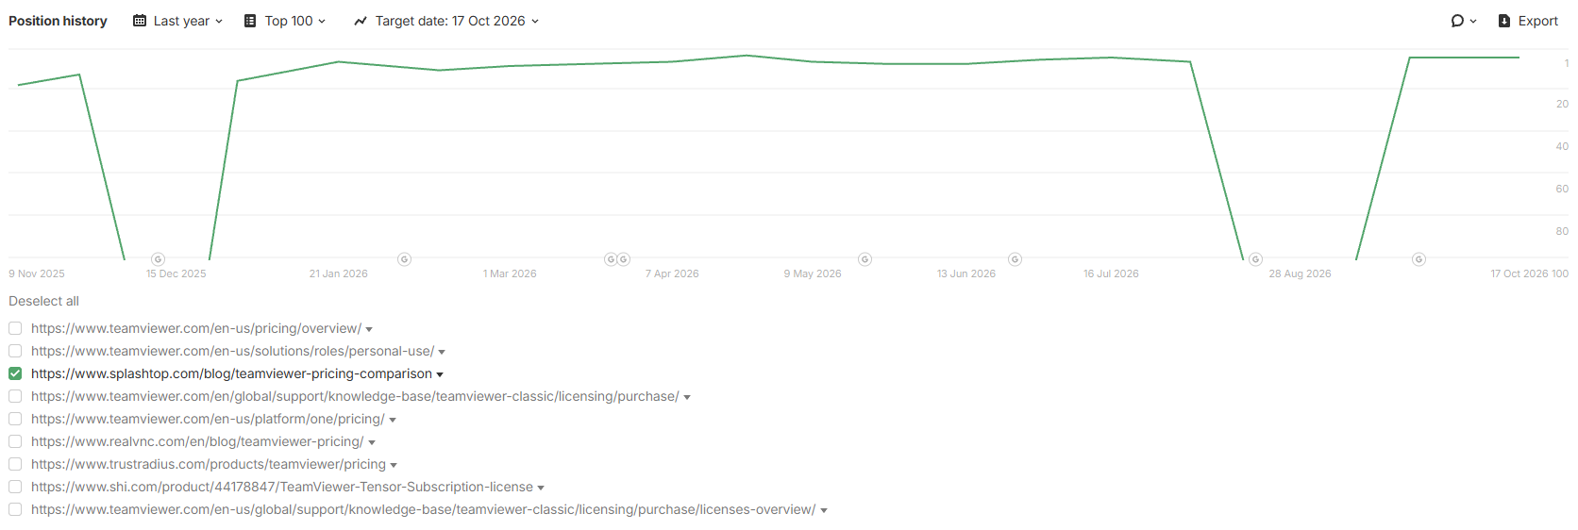
Splashtop continues to maintain Top 5 visibility for “TeamViewer pricing” despite intermittent ranking fluctuations, keeping its comparison page prominent for users evaluating TeamViewer pricing alternatives.

- Sustained Top 5 Visibility for “AnyDesk Pricing”

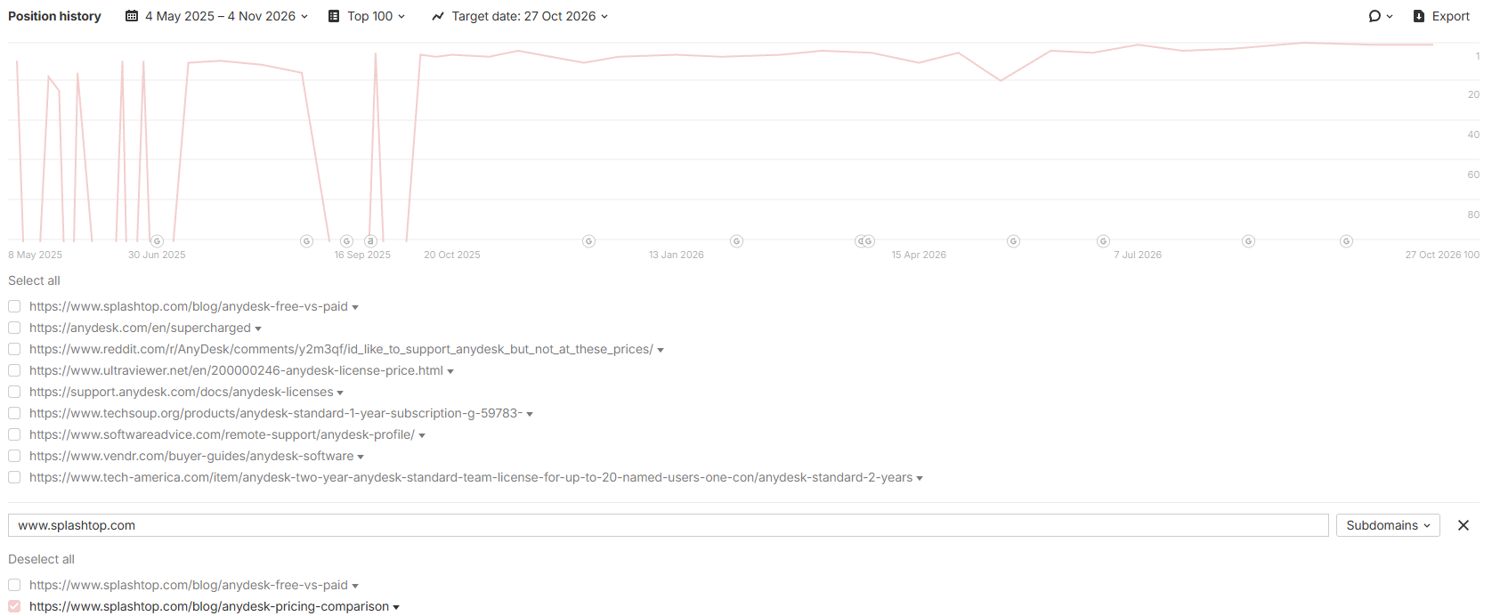

Splashtop continues to maintain strong Top 5 visibility for “AnyDesk pricing,” keeping its comparison content prominent in search results for users evaluating AnyDesk and its alternatives.

- “LogMeIn Alternative” Breaks into the Top 6

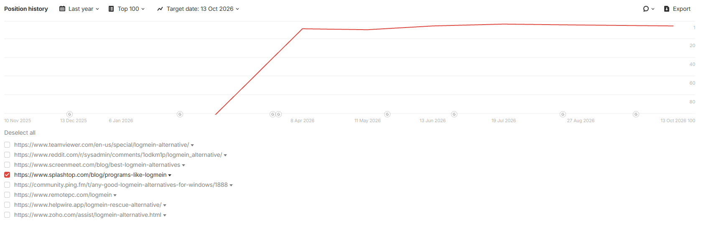
Splashtop’s “LogMeIn alternative” page has moved from outside the Top 100 to sustained Top 5 visibility, with the ranking remaining consistently strong following the initial improvement.

